- When comparing the calculated carbon intensity (CI) of corn- and wheat-based (non-durum) bioethanol, what do we observe?
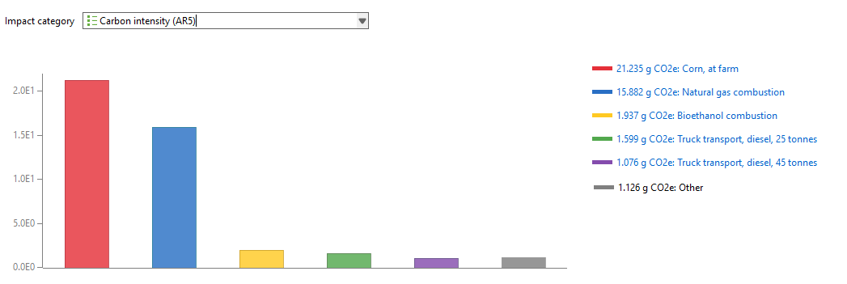
Bioethanol CI from Wheat (non durum) (Global): 15.88 g CO2-eq/MJ
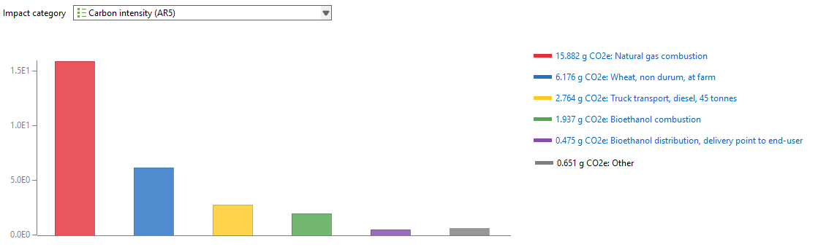

- Why is carbon dioxide (CO₂, biogenic) reported as zero for both corn- and wheat-based (non-durum) bioethanol, even though biomass is used as the feedstock?
Reference: Fuel Life Cycle Assessment Model Methodology (2.8 Life cycle impact assessment methods) - [Link]

- How do these results compare with industry-average values? What strategies could bioethanol plants adopt to further reduce their lifecycle greenhouse gas emissions?
Reference: Clean Fuel Regulations (CFR) data - [Link].

